Test Case: tc002_SPX_Dev5_Crear_Requisicion_Spot_Tipo_Cobro_Project
Step 1 - Enter username and password and click to button Enter: Credentials Entered
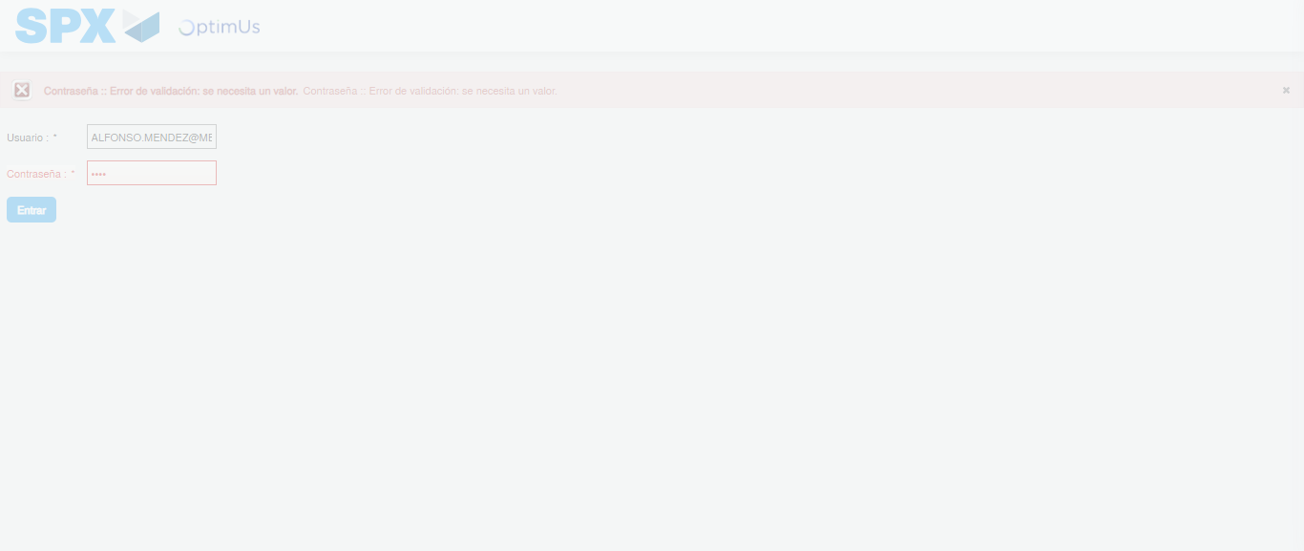Image file-name: QC_Testing-tc002_SPX_Dev5_Crear_Requisicion_Spot_Tipo_Cobro_Project-1783377744143

Step 2 - Select to UEN and Access to Spot Buy Requisitions : UEN Correctly selected and Correct access
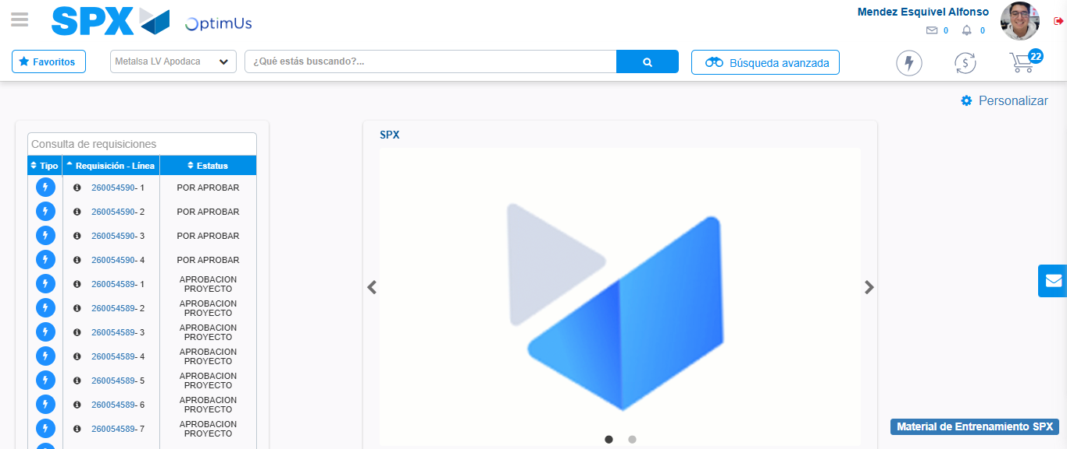Image file-name: QC_Testing-tc002_SPX_Dev5_Crear_Requisicion_Spot_Tipo_Cobro_Project-1783377769347

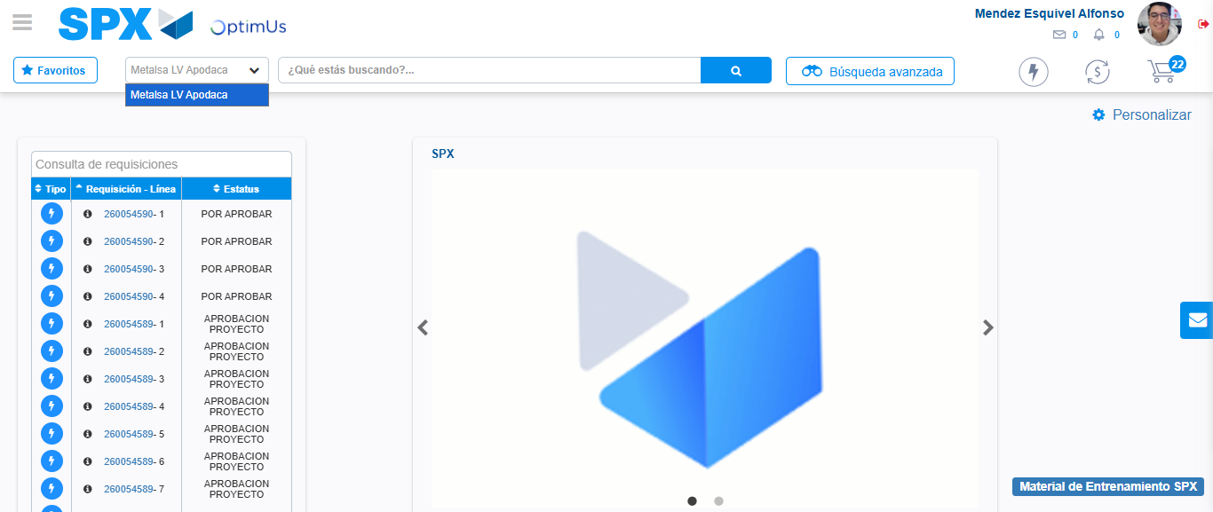Image file-name: QC_Testing-tc002_SPX_Dev5_Crear_Requisicion_Spot_Tipo_Cobro_Project-1783377771954

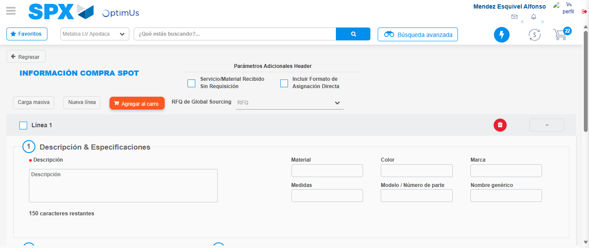Image file-name: QC_Testing-tc002_SPX_Dev5_Crear_Requisicion_Spot_Tipo_Cobro_Project-1783377791783

Step 3 - Data Capture Spot Buy Requisition: Data captured correctly
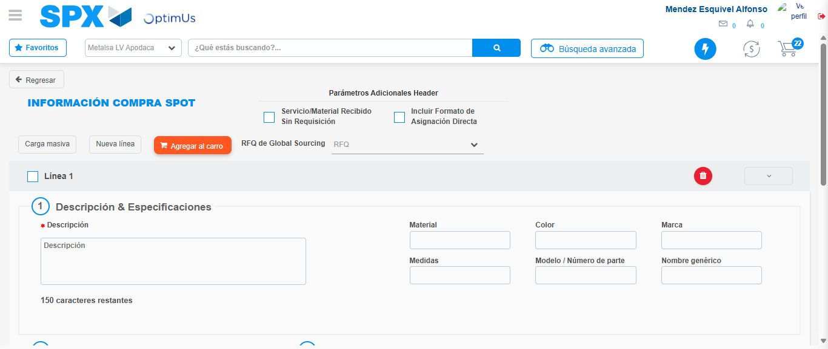Image file-name: QC_Testing-tc002_SPX_Dev5_Crear_Requisicion_Spot_Tipo_Cobro_Project-1783377792053

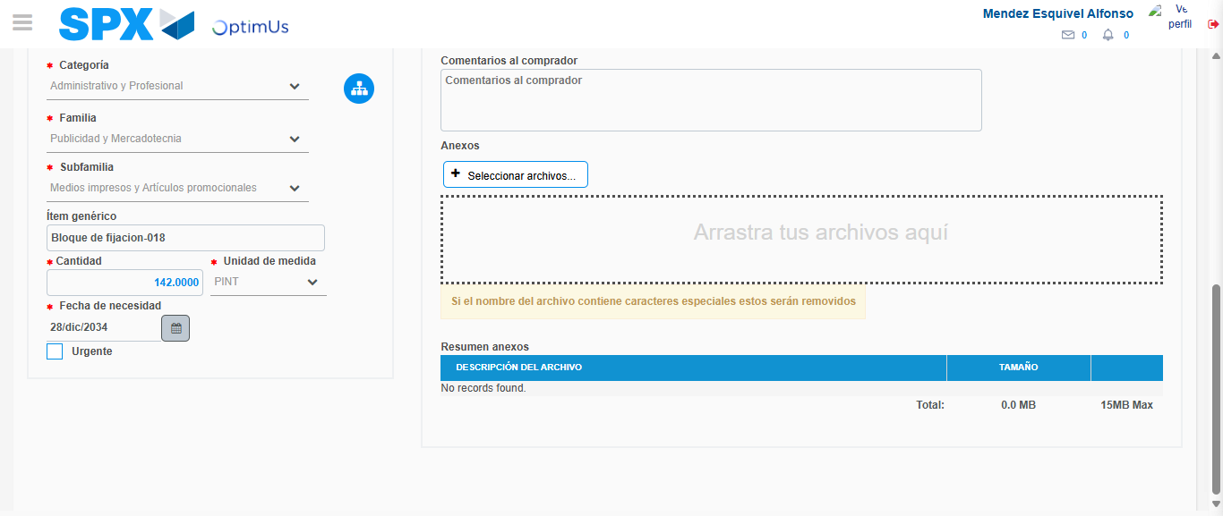Image file-name: QC_Testing-tc002_SPX_Dev5_Crear_Requisicion_Spot_Tipo_Cobro_Project-1783377802705

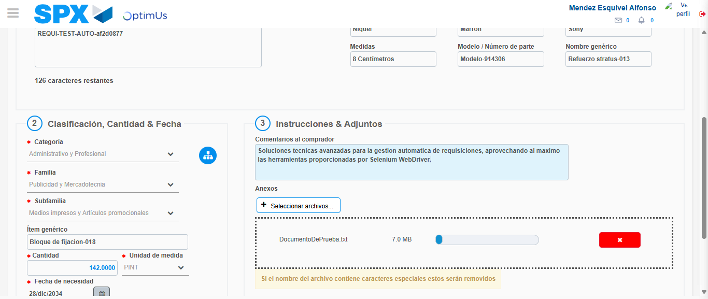Image file-name: QC_Testing-tc002_SPX_Dev5_Crear_Requisicion_Spot_Tipo_Cobro_Project-1783377803518

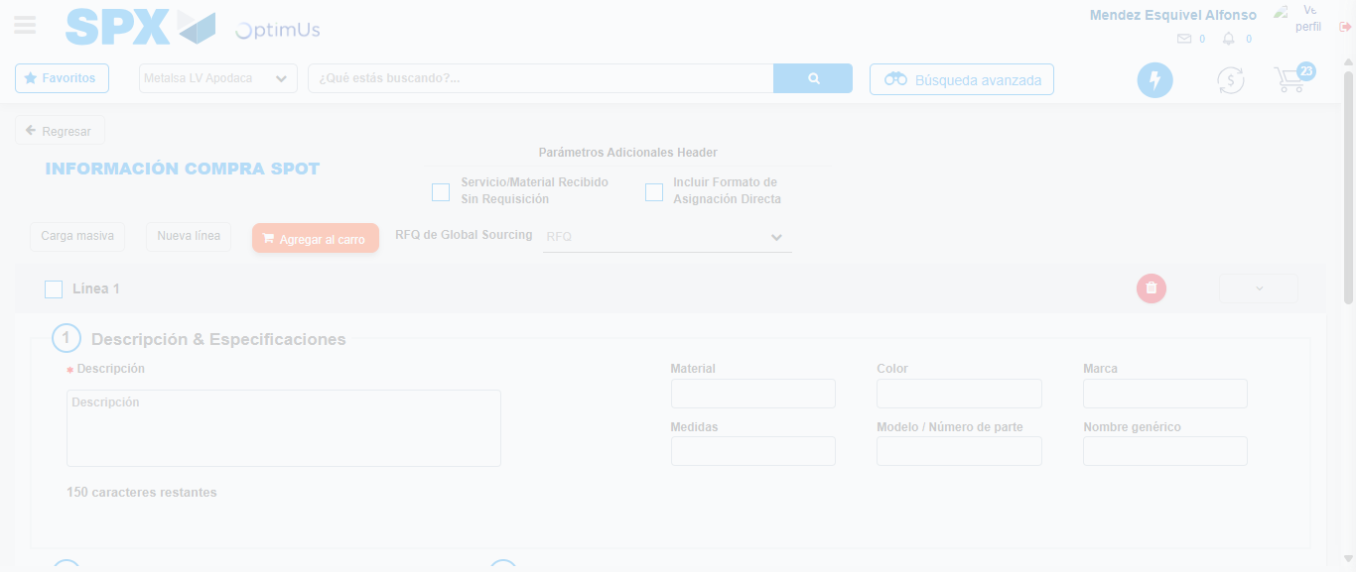Image file-name: QC_Testing-tc002_SPX_Dev5_Crear_Requisicion_Spot_Tipo_Cobro_Project-1783377805478

Step 7 - Return to Main Page SPX : Return to Main Page SPX
Image file-name: QC_Testing-tc002_SPX_Dev5_Crear_Requisicion_Spot_Tipo_Cobro_Project-1783377769347

Image file-name: QC_Testing-tc002_SPX_Dev5_Crear_Requisicion_Spot_Tipo_Cobro_Project-1783377771954

Image file-name: QC_Testing-tc002_SPX_Dev5_Crear_Requisicion_Spot_Tipo_Cobro_Project-1783377791783

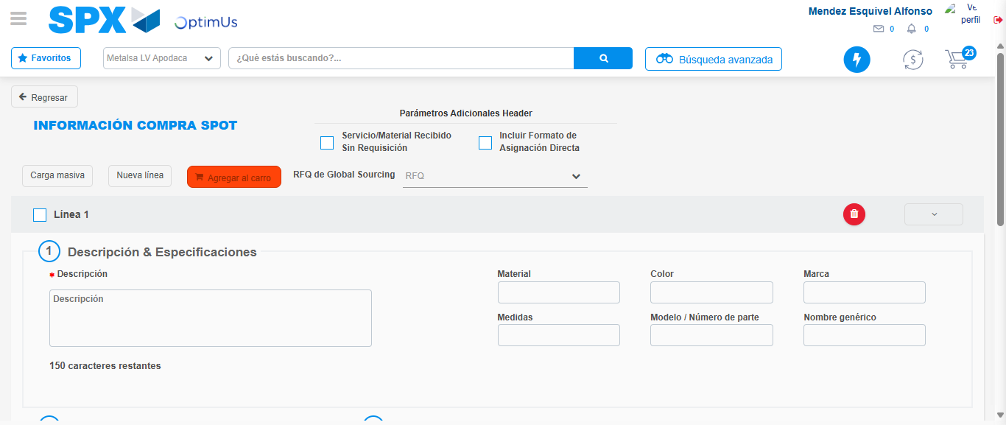Image file-name: QC_Testing-tc002_SPX_Dev5_Crear_Requisicion_Spot_Tipo_Cobro_Project-1783377807676

Image file-name: QC_Testing-tc002_SPX_Dev5_Crear_Requisicion_Spot_Tipo_Cobro_Project-1783377807846

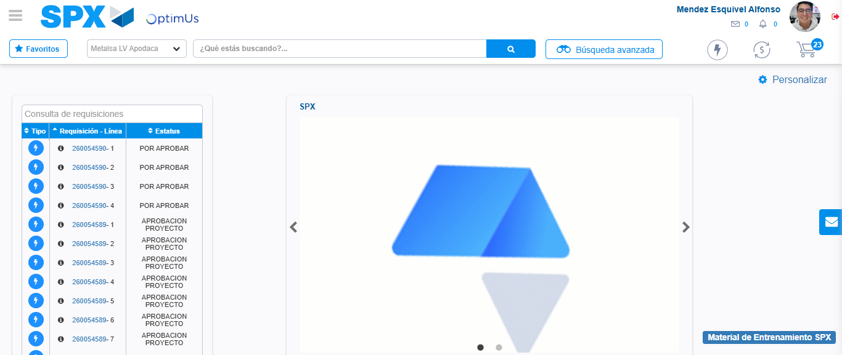Image file-name: QC_Testing-tc002_SPX_Dev5_Crear_Requisicion_Spot_Tipo_Cobro_Project-1783377829023

Step 8 - Log Out : Log Out SPX
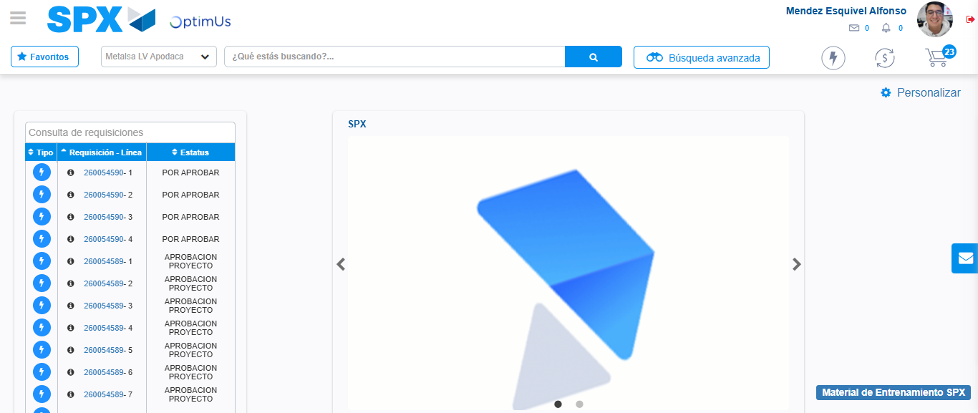Image file-name: QC_Testing-tc002_SPX_Dev5_Crear_Requisicion_Spot_Tipo_Cobro_Project-1783377829259

